**Client Appreciation Specials for January & February**

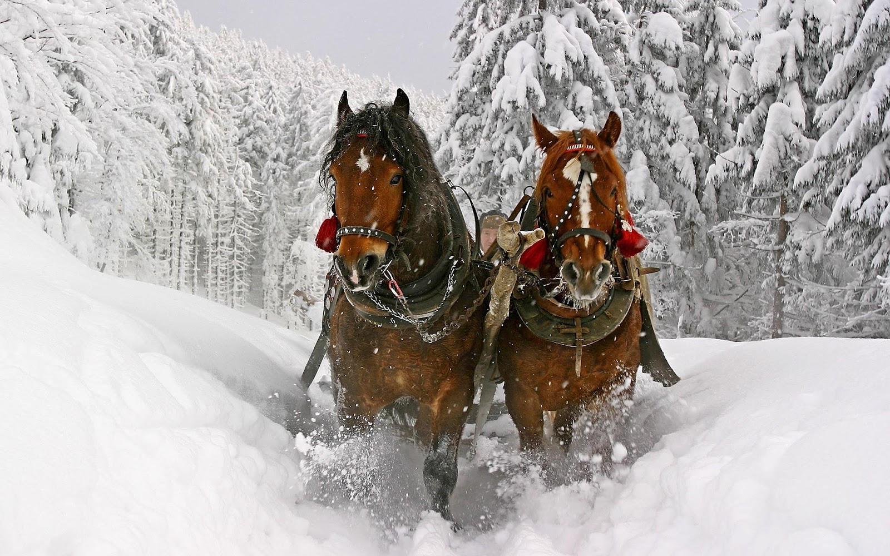



**X-Ray Special**

Current clients receive special pricing on Foot or Hock Baseline Radiographs (X-Rays). Radiographs will be kept on file in your horse's medical records. Hoof X-rays will be sent to your farrier at your request. ***Offer does not include Lameness Exam or Pre-Purchase Consulting.***

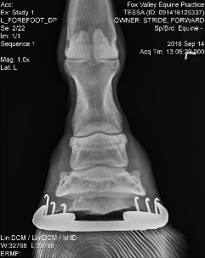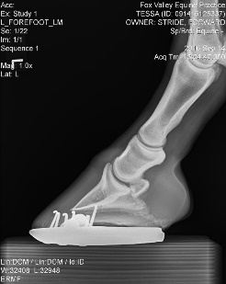

**Bloodwork Special**

**Digital Radiograph Foot Set**  
Lateral & DP View of each front foot

|  |  |
| --- | --- |
| **Discounted Prices on Bloodwork** | |
| **CBC and Chemistry** | $80 |
| **Insulin** | $50 |
| **Thyroid (T4)** | $25 |
| **Coggins Test** | $37 |
| **ACTH** | $70 |
| **Senior Panel** (CBC/Chem, Insulin, ACTH, T4) | $215 |

**$100**

**Digital Radiograph Hock Set**2 Views of each hock

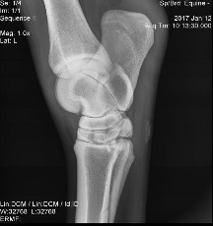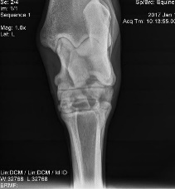

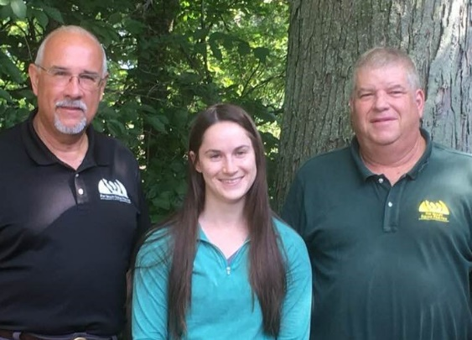

**$100**

Dr. David Heinze Dr. Paige Billek Dr. Dale Stapleton

**630-365-5600  
 www.foxvalleyequine.com**

**No trip charge for 5+ horses**